Chapter 6: Dissecting Model Visuals focuses on examples of what to do to make certain parts of visualizations stand out while de-emphasizing others. Some things to keep in mind are the color, font size, labeling, alignment, and positioning. The visuals below are some that I have made that highlight some, but certainly not all, of the ideas that this chapter covered.

This visual is a bar plot of the area of a plot of land vs. the sale price of that plot of land. The title is labeled at the top and the axes are labeled with the appropriate labels. The visual might be better viewed horizontally on a landscape view due to how large it is horizontally. Green was used to color the bars because it is easy to distinguish from black and white. The bars also have a black outline on them, so that they are easy to differentiate from the other bars. The actual sale price is labeled above the bars so that the reader does not need to estimate what the area of the lot is.

The visual to the right depicts the total amount of fine revenue from parking tickets for certain districts in the city of Buffalo for a.m. and p.m. It is a stacked bar chart. The reader’s attention should be on the stacked bars and notice that it appears that more parking tickets are issued in the evening than in the morning.

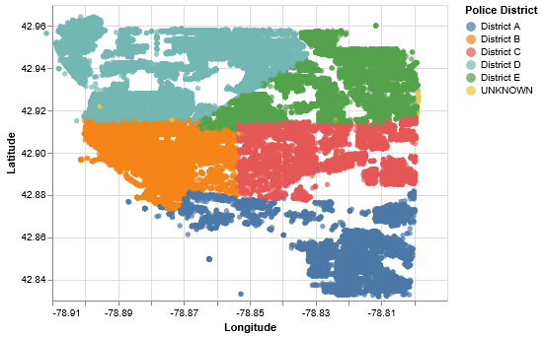The y-axis (total fines) labels should probably be in millions so there are not so many zeros taking up space and the plot is missing the title. However, the x-axis (council district) is clearly labeled.

The visual below shows the lat-long position of each of the parking ticket data for the city of Buffalo from the graph above, but this graph is by police district. Again, there is no title. Attention should be given to the legend that states the police district by corresponding color as well as the distribution of colors on the map. The map has clear whitespace and may indicate that those locations may not be accessible to parking. It should also be noted that based on the ticket data, there are clear division lines between the police districts. This graph is not a fully comprehensive graph of the geographical locations, but could be further enhanced by placing a background of land reference of Erie county in the whitespace.